Question 1: /Users/josh/Library/Mobile Documents/com~apple~CloudDocs/EMU/Third Year/Semester 1/COSC 381/Assignment/Lab 5/src/HelloWorld.java

Question 2: 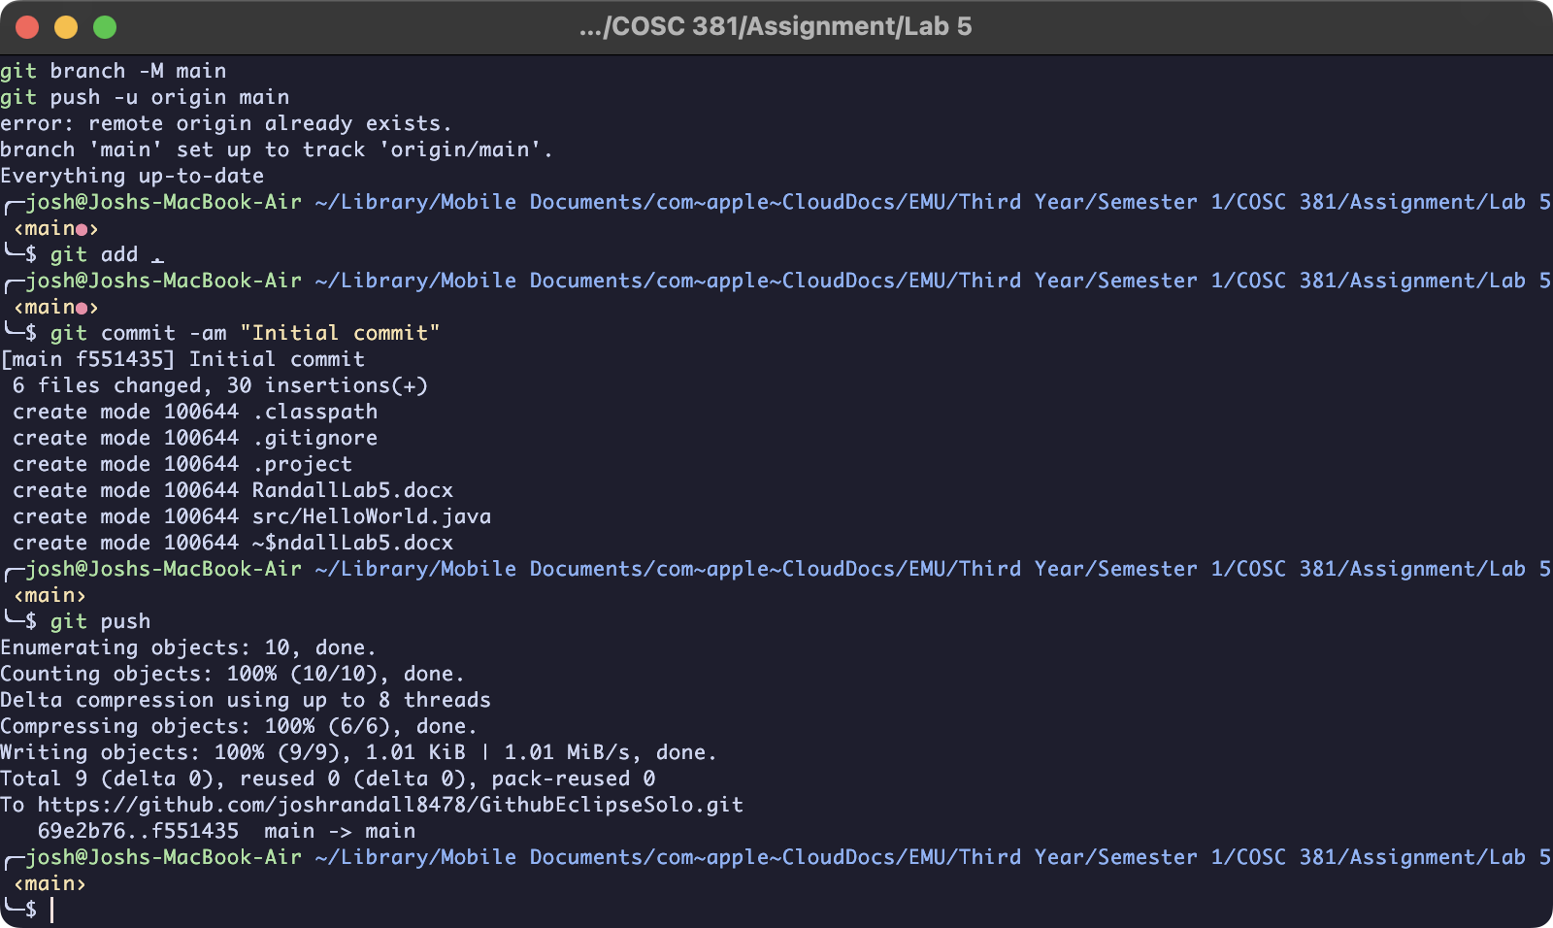

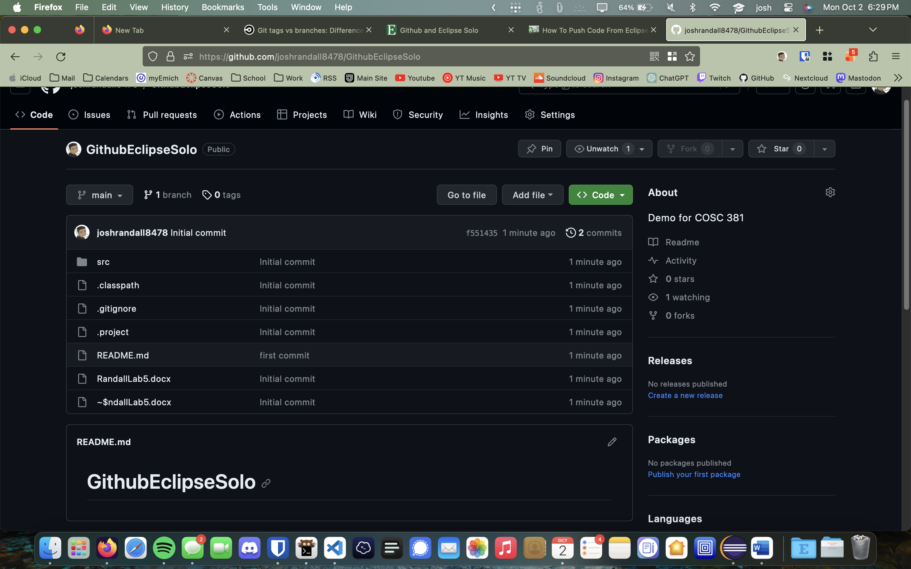

Question 3:

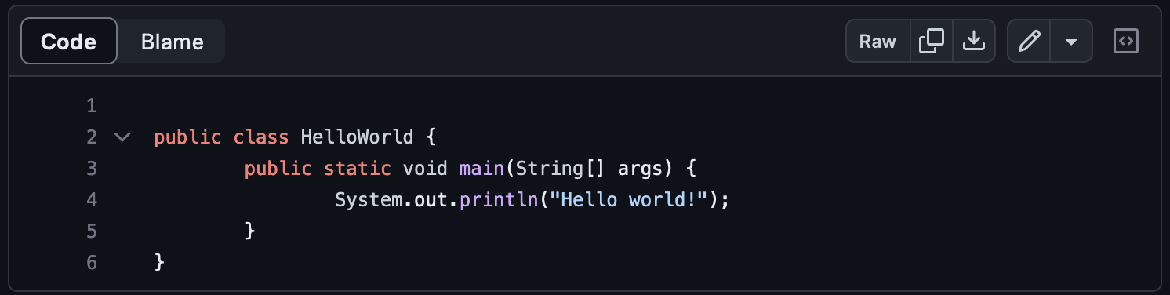

Question 4:

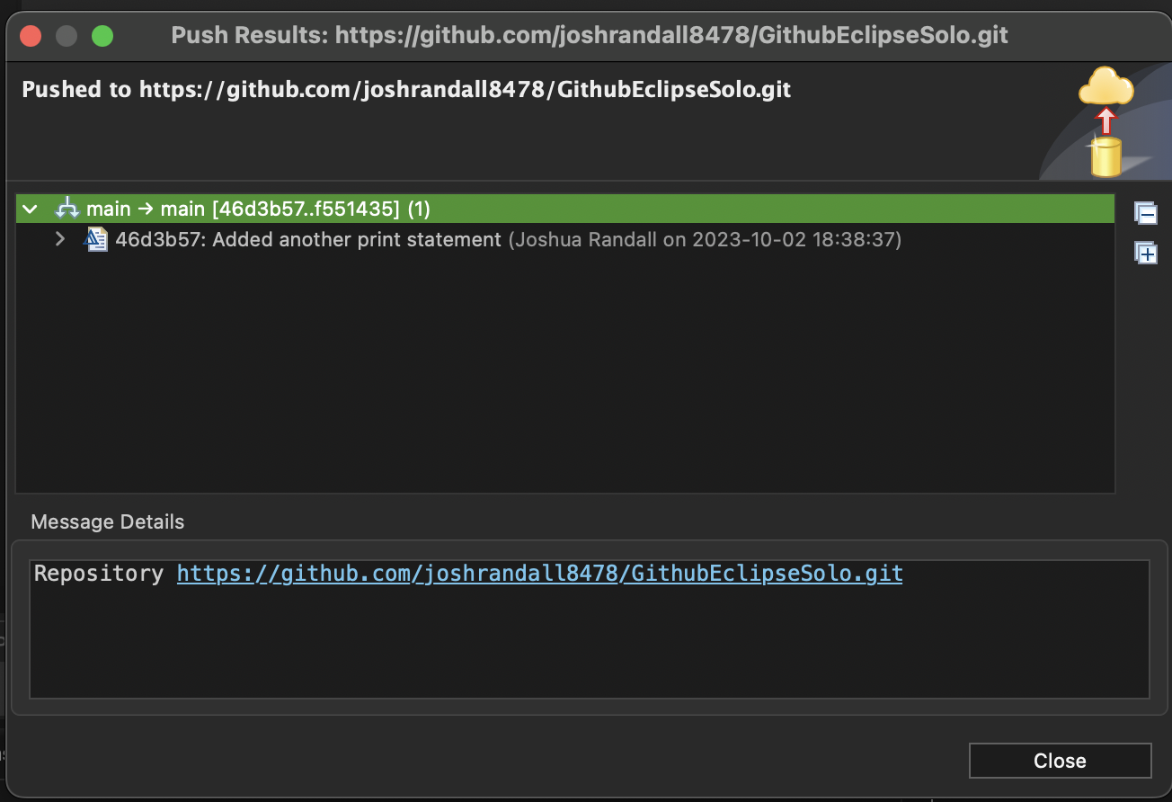

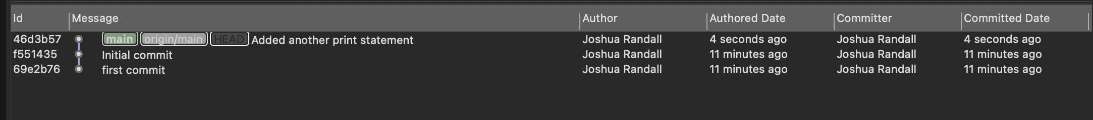

Question 5: 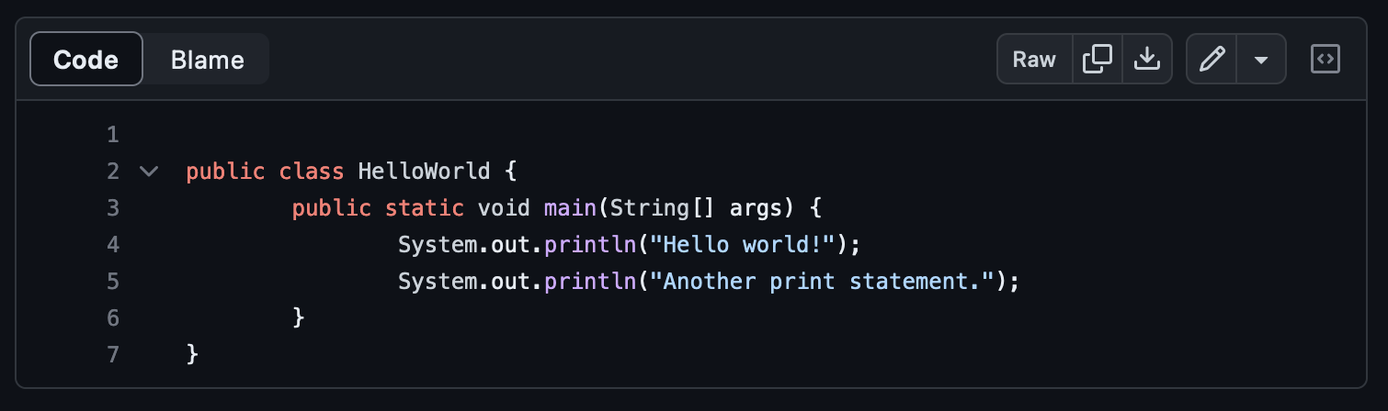

Question 6:

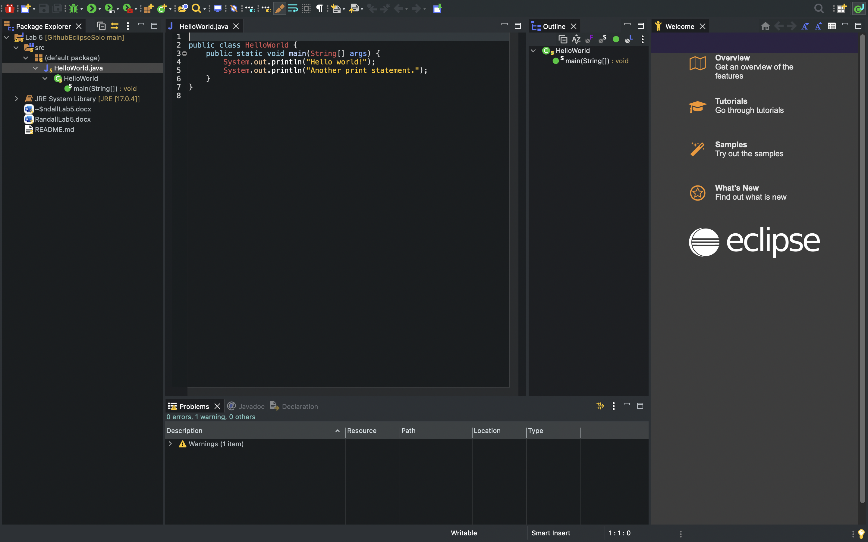

Question 7:

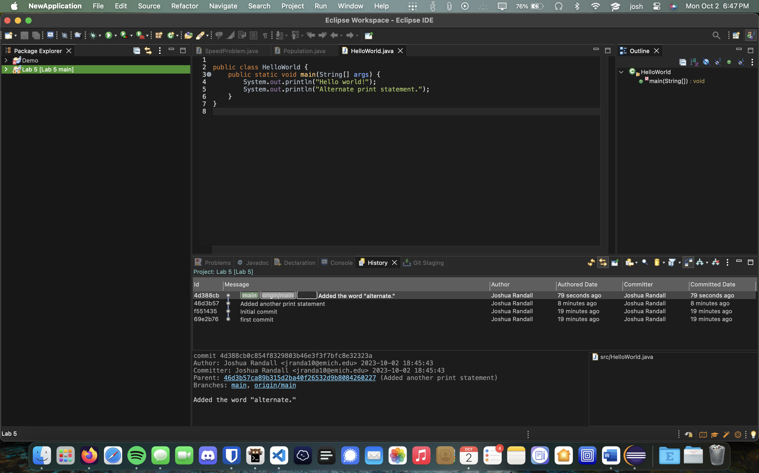

Question 8:

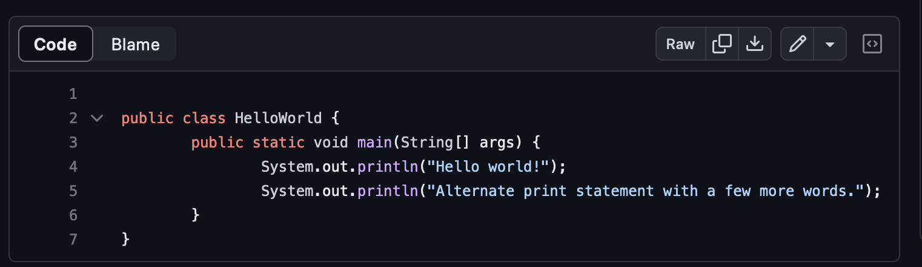

Question 9:

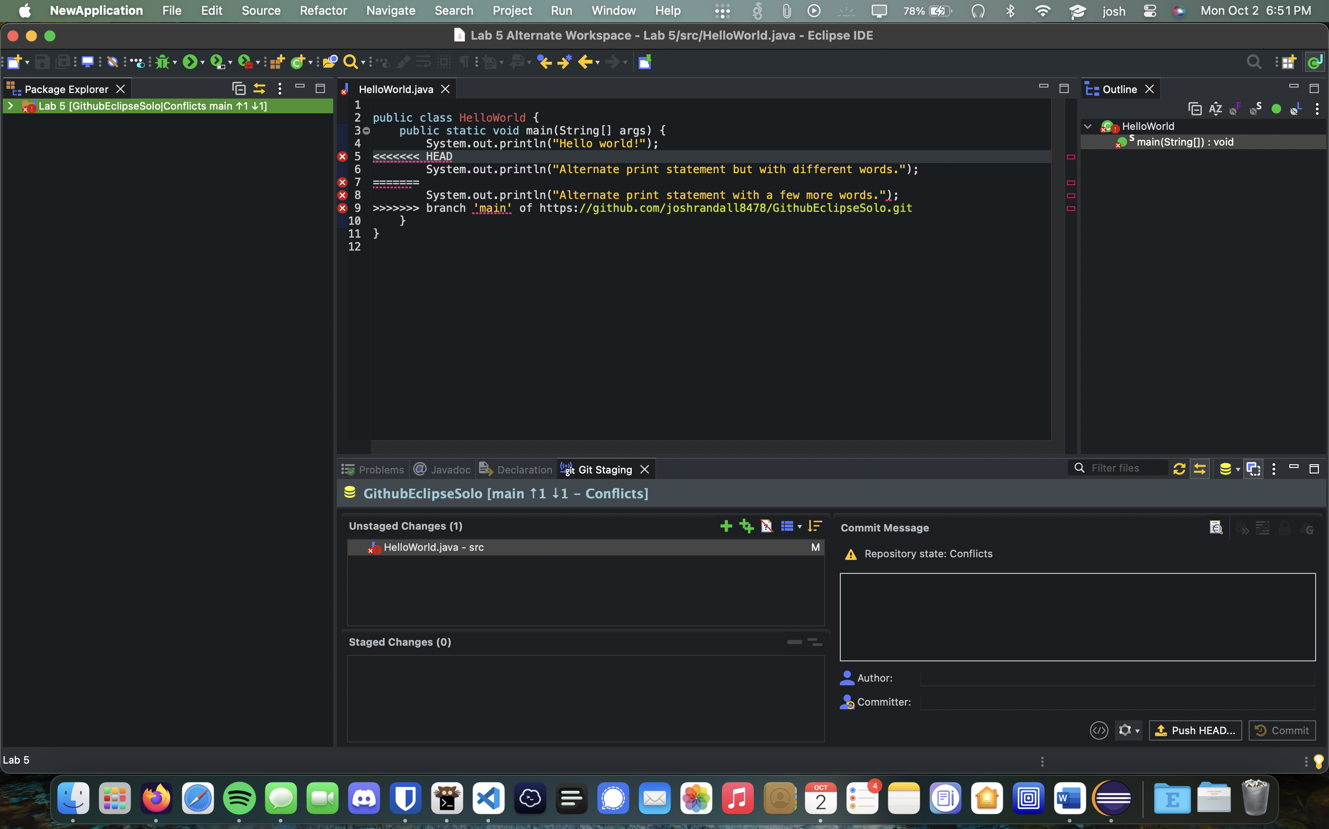

Question 10:

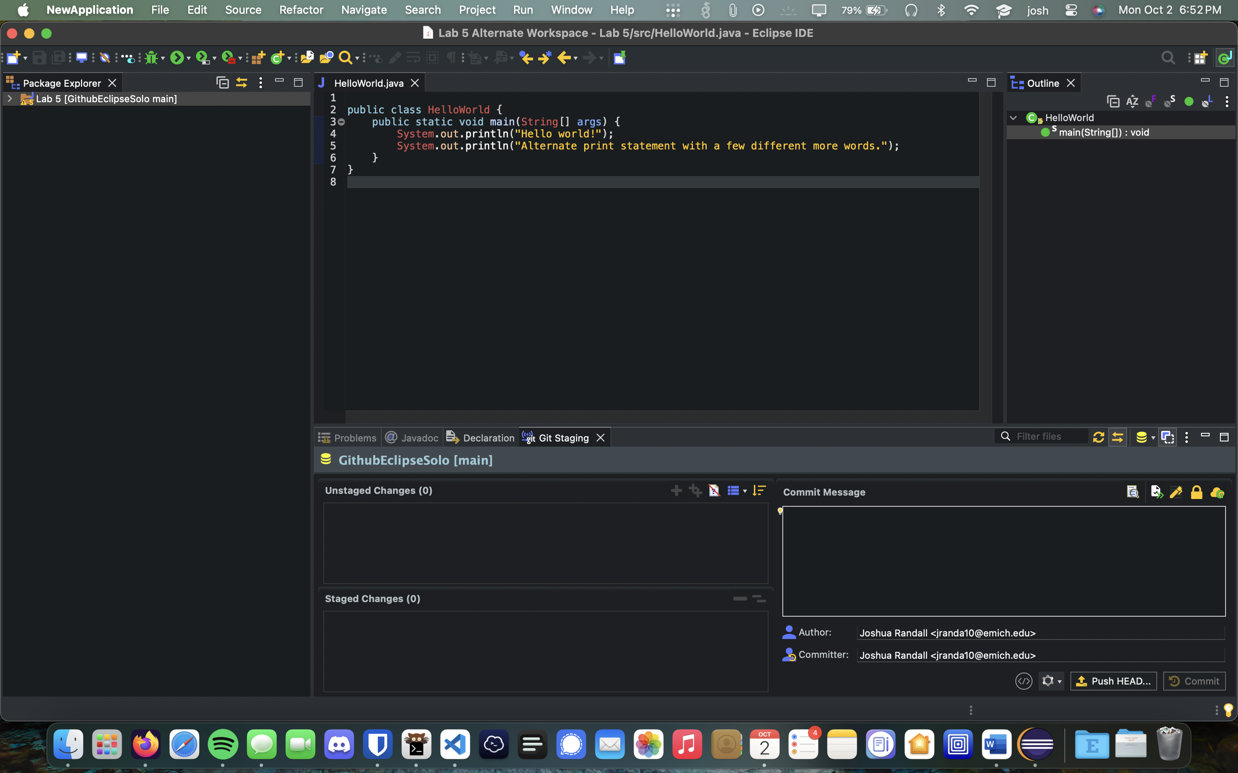

Question 11:

